3.3 Data Flow Diagram and User Stories
A Data Flow Diagram (DFD) represents the information flows within ComicCraft, showing how data enters and leaves the system, how it is processed, and where generated data is stored.

DFD Level 0 – ComicCraft
ComicCraft is a web application built with FastAPI that turns a user's story prompt into a five-panel comic with illustrations using Gemini Flash, Gemini Pro and Stable Diffusion.
- User (Browser): sends the story prompt, character name, setting, tone, art style and download request; receives the comic preview, PDF and export success page.
- Google Gemini API: receives outline and narration prompts; returns the panel outline and the story narration with dialogue.
- Stable Diffusion (Diffusers): receives panel image prompts; returns the generated panel images.
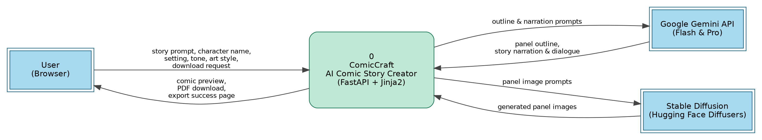
DFD Level 0

DFD Level 1 – ComicCraft
- User opens the ComicCraft web page and fills the form: story prompt, character name, setting, tone and art style.
- FastAPI (main.py, routes.py) receives the form data through a POST request and renders pages with Jinja2 templates.
- Gemini Flash generates a structured five-panel outline: panel number, title, scene description and an image prompt.
- Gemini Pro expands the outline into narration and character dialogue for every panel.
- Stable Diffusion (Hugging Face Diffusers) creates a comic-style image for each panel's image prompt. Images are saved in static/panels (D1).
- layout_builder.py matches each image with its panel text and builds the comic layout.
- comic_preview.html shows the comic panel by panel to the user.
- On download, exporters.py compiles the layout into a PDF with FPDF, saves it with a timestamp in static/exports (D2) and redirects to export_success.html.

Data Stores
- D1 Panel Images: generated panel images in static/panels.
- D2 Comic PDFs: exported comic PDFs in static/exports.
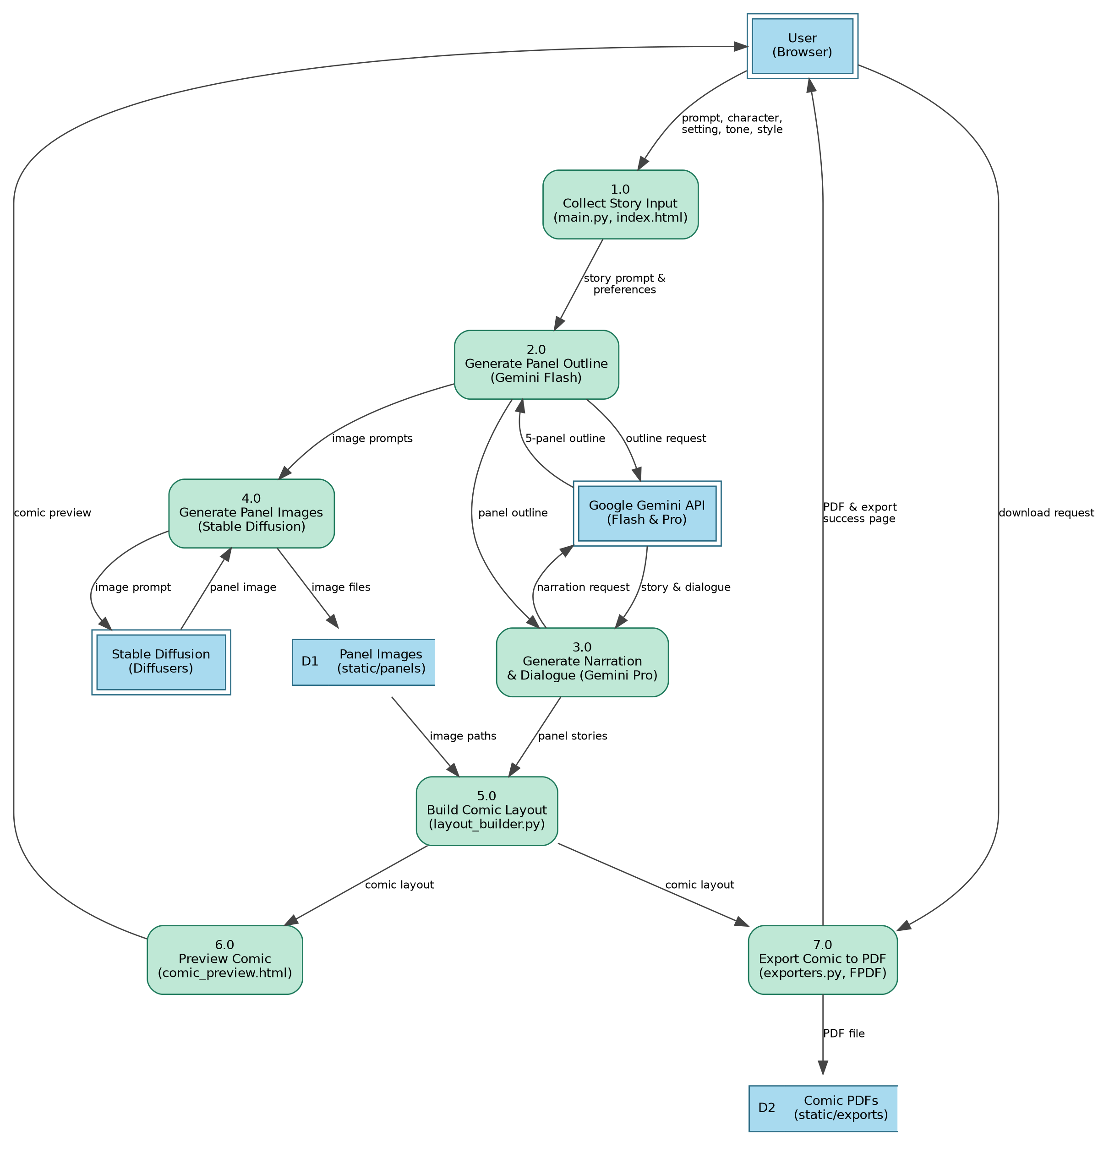
DFD Level 1

User Stories
The project document defines user stories for the ComicCraft workflow, covering story input, AI story generation, image generation, frontend access, comic preview, PDF export, backend integration, testing and documentation.

